Name: Class:

Task 1
Think of a webpage or website that you often visit.
(a) Write the URL below.
URL:

(b) Write the domain name or host name below. (The domain name would be duckduckgo.com, whilst an example of a host name would be www.duckduckgo.com).

(c) Make use of the ping utility to find out the IP address of the domain name.
If you have access to a command prompt or terminal window, enter the command:
ping <domainName>
Otherwise, make use of an online ping utility such as:
https://www.site24x7.com/ping-test.html
https://www.ipaddressguide.com/ping
State the IP address of the domain name you gave in (b)

(d) Find the IP address of your computer (or the router that is connected to the Internet).
Make use of an online utility to do this such as:
https://whatismyipaddress.com/

(e) Complete the below diagram to explain what happens when the user requests the browser finds the URL (web address) you gave in part (a).
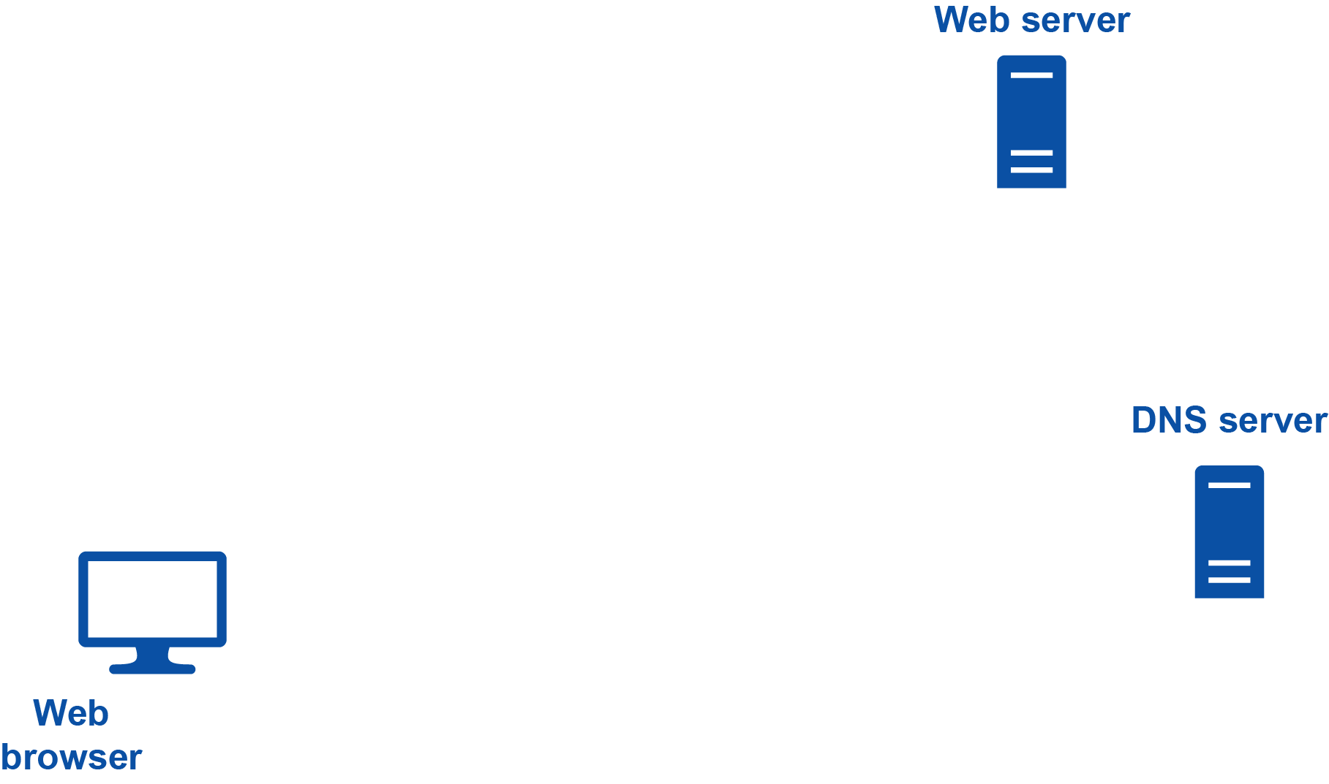

Task 2
Complete the table below by carrying out the following:
- Visit two e-commerce websites and add items to the shopping basket. Close the browser, then return to the websites to see if they still have the items to determine if they were using persistent cookies or session cookies.
- Log in to two further websites that you use. Close the browser, then return to the websites to see if they have remembered your log in. Determine if they are using persistent cookies or session cookies.
Web address | Website name | Does the website remember the items in your basket, or that you are logged in? | Does the website use persistent cookies or session cookies to do this?

Task 3
Find a list of the cookies that were sent to you.
An online help guide should be able to help you view cookies, such as:
https://www.wikihow.com/View-Cookies
Write down the names of some of the cookies and what information is stored in them.

